# HexitecGigE User Manual LOGO

Author: Christian Angelsen

Date: 26/04/2018

Version: 1

1.1



# Introduction

This document describes the different elements of the HexitecGigE GUI, and how it can be used to acquire, process and display data. The initial version will outline the different tabs and elements, while later on more details will be added for each.

# GUI Main Window

Initially it may appear confusing, but two elements of the mainwindow are always visible within the GUI. Apart from the drop-down menus at the very top, the program toolbar is ever present:



Figure - The program toolbar.

The icons of the toolbar provide the following functions:

* Start DAQ - start data acquisition, more settings on the Data Acquisition tab.
* Stop DAQ - stop data acquisition.
* Turn on HV - Switch the high-voltage on.
* Turn off HV - Switch the high-voltage off.
* Clear active image - Remove the selected image.
* Load data or script – Display HXT file contents.
* Zoom in - Magnify currently selected image.
* Zoom out - Make currently selected image smaller.
* Toggle grid - Make grid visible between each pixel.
* Toggle colour bar - Hide/Show the colour bar to the right of the image.
* Cycle colour map - Cycle through 8 different image colour schemes.

The second, always visible element is the Application Output pane seen in Figure 2.

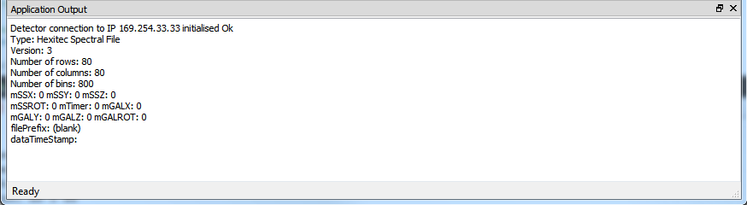

Figure - the Application Output.

It will display information or error messages. Error messages will be highlighted in red where aSpect generally point to a detector error while Pleora implies an issue with the data connection. However, it’s not uncommon for an error to list both.

# Visualisation Tab

The Visualisation Tab is the tab always shown first when the program has loaded. Its main task is to display image data. A key part of this tab is shown in Figure 3 which illustrates how the pixel by pixel histograms of processed data are displayed. Data saved in HexitecGigE’s HXT format can be opened using the  icon in the program toolbar. The  icon is used to close an opened image. Alternatively, click on the File drop-down menu to access the same actions.

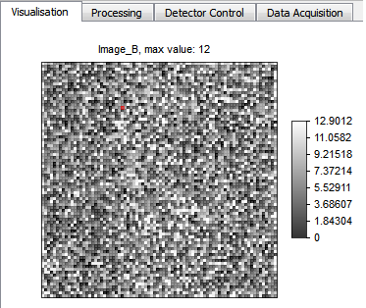

Figure 3 - Pixel Histograms.

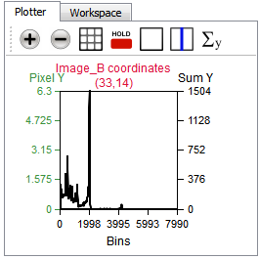

Figure - The Plotter.

The Plotter is employed to further interrogate HX T data. Double-clicking a pixel in the image will plot that histogram inside the Plotter’s graph, as seen in Figure 4. It’s possible to zoom into greater detail by left clicking and dragging the mouse across a portion of the plot. Alternatively, the + icon will also zoom in, while the - icon will zoom out. Apart from the two Zoom icons, there are 5 more icons as shown in Figure 5.



Figure - The Plotter toolbar.

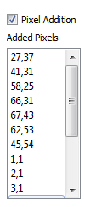

Figure - Pixel Addition.

The two zoom icons aside, the others provide:

* Toggle Grid - Toggle a 5x4 grid across the plot.
* Toggle Hold - Hold more than one pixel histogram in the Plotter.
* Clear Plot - Clear all but the current pixel histogram from the Plotter.
* ***Toggle X Explorer - ???***
* ***Toggle Sum Explorer - ???***

Just to the right of the Plotter is the option of Pixel Addition. ***What does it actually do??***

The ProgressViewer shows the detector status as seen in . Additionally, the two progress bars indicate the progress of the current data capture versus the overall progress. For further details, see the Data Acquisition tab.

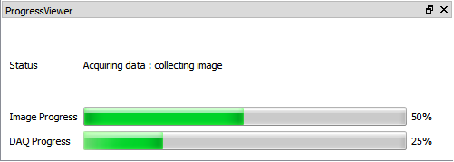

Figure - The ProgressViewer.

The ThumbViewer will list of the thumbnails of data currently displayed. As can be seen from Figure 8, there is an associated toolbar. The + and - icons provide zoom in and zoom out respectively. The padlock toggles the colour bar on and off and the colourful wheel icon will cycle through 8 possible colourmaps.

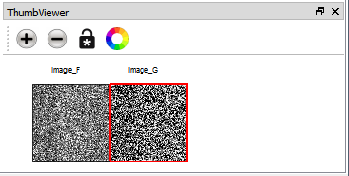

Figure 8 - The ThumbViewer.

# Processing Tab

Figure 9 shows the Processing Tab and the processing options. These determine how the data is to be processed, whether the data is acquired live or manually from file(s).

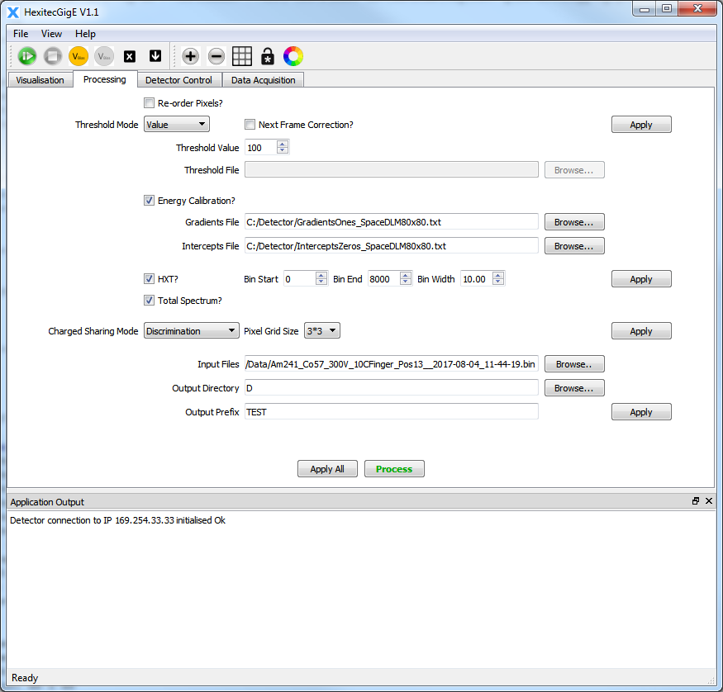

Figure 9 - The Processing Tab.

***What does re-order pixels do?? “HXT?” does what? Total Spectrum?***

The **Threshold Mode**’s three choices are no threshold, a uniform value threshold or individual pixel thresholds from file. Energy Calibration can be toggled on or off, where a **Gradients file** and an **Intercepts file** provide an individual value for each pixel. The calibration is calculated as y = m*x + c, where x is the pixel value, m is the Gradients value

and c is the Intercepts value. The **Bin Start, Bin End** and **Bin Width** set starting, ending and width parameters of the pixel histograms. If **Charged Sharing Mode** is selected, there are two options: Addition and Discrimination. The dropbox next to it selects either 3x3 or 5x5. These choices mean the algorithms look at either the surrounding 8 or 16 pixels respectively. The three edit lines labelled **Input Files**, **Output Directory** and **Output Prefix** control manual processing. They specify the location of binary file(s) to be processed, where the resulting HXT file should be placed and any prefix to said HXT file.

Finally, each **Apply** button is used to commit each associated setting(s). The **Apply All** button will commit all changes and the **Process** button will commence manual processing of the selected file(s).

# Detector Control Tab

Figure 10 shows the Detector Control tab which provides access to different detector settings, as well as environmental variables and the detector status.

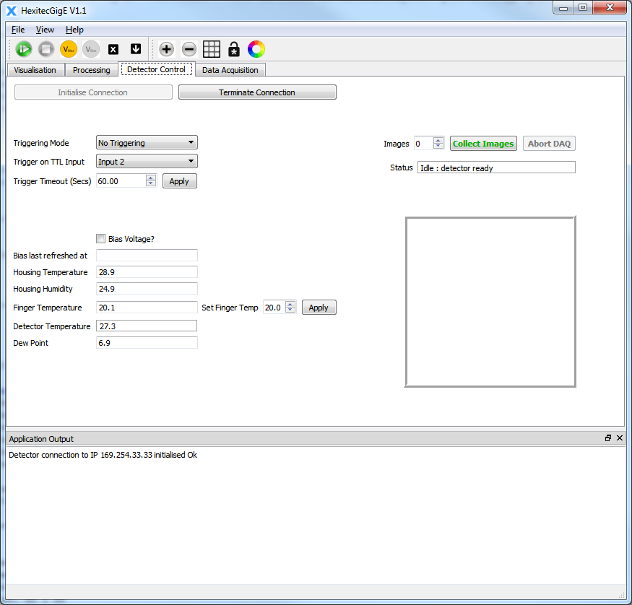

Figure - Detector Control.

**Initialise Connection** and **Terminate Connection** opens and closes the detector connection. **Triggering Mode**, **Trigger on TTL Input** and **Trigger Timeout (Secs)** configures the detector’s trigger setup.

***Bias voltage? = ?? (Doesn’t interact with high-voltage on/off icons)***

There are a set of read only information: **Bias last refreshed at**, **Housing Temperature**, **Housing Humidity**, **Finger Temperature**, **Detector Temperature** and **Dew Point.**

**Set Finger Temp (what is finger temperature? Only range of 17.5 - 25.5)**

The right side shows the current detector Status. It’s also possible to collect a fixed number of images which are displayed in empty frame in rapid succession.

# Data Acquisition

The Data Acquisition Tab is shown in Figure 11. It provides access to acquisition specific settings.

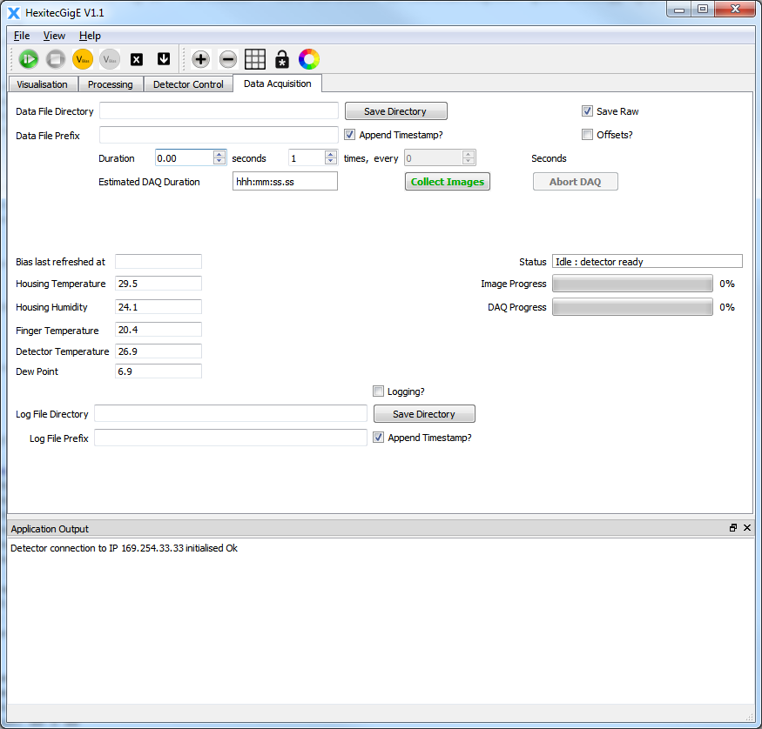

Figure - Data Acquisition.

**Data File Directory** and **Data File Prefix** determine directory and prefix for the file(s) containing acquired data. The duration, number of times and optional pause in between each acquisition, are set by the spin boxes between the labels **Duration, seconds**, **“times, every”** and **Seconds**. There is also an **Estimated DAQ Duration** and two buttons **- Collect Images, Abort DAQ** - to begin and abort data acquisition respectively. The tick box **Save Raw** will save raw binary files of unprocessed acquired data.

***Offsets?*** *= ??*

Six of the environmental parameters from the Detector Control Tab are duplicated here, as is the detector Status information. The two progress bars which are duplicated on the Visualisation Tab are also present. Logging can be toggled on or off. If logging is selected then timestamps may be appended. The log file directory and log file prefixed name are set using **Log File Directory** and **Log File Prefix**.

# Known Bugs

* **Workspace:** If the user clicks on the Workspace part of the visualisation Tab, there is some image specific information here. But clicking on any of the parameters, such as File Name will crash the GUI.
* **ThumbViewer:** Toggling the colour bar on (using the “padlock” icon), dramatically changes the currently selected thumbnail. But toggling the colour bar off will restore its original appearance.
* **Plotter:** Clicking on either **Toggle X Explorer** or **Toggle Sum Explorer** turns the image completely black. Although individual pixel histograms remain unaltered..